**A Method For Treating Liver Toxicity And Disorders:**

**A Novel Method For Reducing The Liver Toxicity Of A Liver Damaging Agent And Treating Liver Disease And Disorders By Altering The Circadian Rhythmicity Of Microbes In The Gut Microbiome**

|  |  |
| --- | --- |
| **Project Number:** | 1869 |
| **Principal Investigators:** | Prof. Eran Elinav  Prof. Eran Segal |
| **Patent Status:** | Pending |
| **Last Updated:** | 26-08-2018 |

**Overview**

**A novel method for treating liver disease and toxicity by programming transcriptional oscillation of the liver through manipulation of the circadian rhythmicity of microbes in the gut microbiome.**

**Background and Unmet Need**

The human intestine carries a vast and diverse microbial ecosystem associated with a host of physiological conditions ranging from obesity and diabetes to autism and mental health. Like its human host, the intestinal microbiota undergoes circadian oscillations manifested in changes in composition and biogeography.

The human circadian clock adjusts physiological processes to diurnal environmental variations through the coordination of transcriptome oscillations in the peripheral tissues. In each individual cell the rhythmic transcriptional program is carried out by a network of transcription factors. These transcription factors determine the fraction of genome undergoing oscillating expression in a tissue specific manner. As a result, up to 20% of the tissue’s total transcriptome and up to 50% of the transcript in the body consist of oscillating elements, which in turn determine the diurnal pattern of cellular and organismal activity.

The labs of profs. Elinav and Segal have discovered that the diurnal microbial behavior drives global programming of the host circadian transcriptional, epigenetic, and metabolite oscillations. Disruption to the microbiome rhythmicity not only abrogates normal chromatin and transcriptional oscillations of the host, but also incites genome-wide de novo oscillations in both intestine and liver.

Hepatic drug detoxification and hepatotoxicity are strongly tied to the liver’s homeostatic diurnal variation. This in turn means that through the identified host-microbiome diurnal interface we can modulate and treat different liver conditions associated with disruption of the microbiota and circadian clock.

**Consequently, there is a strong need for the development of novel methods for analyzing and modulating the gut microbiota composition and oscillations for the treatment of liver disease and toxicity.**

**The Innovation**

The teams of Profs. Elinav and Segal have found a link between the body’s circadian clock and oscillations in the host’s gut microbiome. This link is reciprocal and thus, by manipulating the gut microbiome, different medical conditions can be treated by affecting circadian clock activity in different tissues.

**The Technical Essence:**

The Elinav-Segal research teams discovered that the host’s gut-microbiome influences rhythmic host physiology beyond the intestine by driving systemic metabolic rhythms and programing of transcriptional oscillations in the liver. This finding can be used in a number of ways to treat different liver diseases and drug toxicities: first, by administering different agents such as antibiotics, probiotic, polyamines or fecal transplants to alter the circadian rhythmicity of an individual's gut microbiome, thereby reducing the toxicity of the liver damaging agent. Second, by analyzing the circadian rhythms of specific gut microbes, an ongoing treatment regimen can be modified for better results.

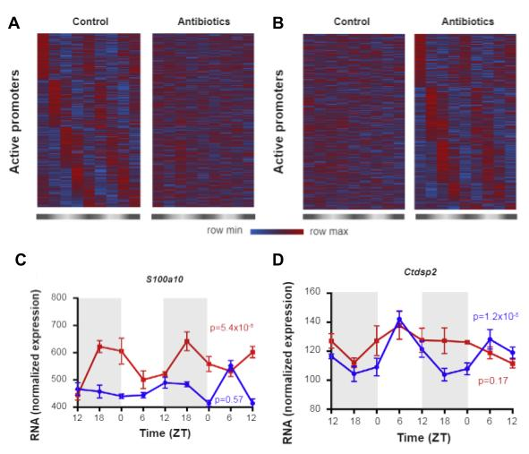

Comparing active promoter oscillations in intestinal epithelial cell that are gained (A) or lost (B) after administering antibiotics. Figures C & D show gene expression oscillations that are either gained (C) or lost (D) after administering antibiotics.

**Applications and Advantages:**

* **A method for treating liver disease by altering gut microbiota oscillations which can supplement and augment other therapeutic methods.**
* **Analysis of the gut microbiome’s composition, oscillations, and metabolome can help improve ongoing treatment regimens.**

**Development Status**

The teams of Profs. Elinav and Segal have tested the effect of different agents on microbiome oscillations in mice and rats and have shown that affecting the microbiome of lab animals can alter transcriptional oscillation in the host cells. Additionally, they have demonstrated that treating mice with antibiotics can reduce the hepatotoxic effects of a model drug (paracetamol).

**For additional information please contact:**

Dr. Shay Sela  
VP Business Development Life Sciences  
Tel: +972.8.9344095  
Email: Shay.Sela@weizmann.ac.il